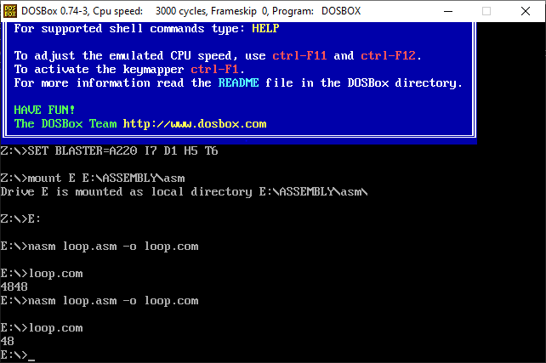TASK #01:

ORG 100H

MOV AX, 1

MOV CX, 20

MOV DX, AX

L1:

call print

ADD AX, 1

LOOP L1

MOV AX, 4C00H

INT 21H

print:

PUSH AX

PUSH DX

PUSH CX

MOV BX, 10

XOR CX, CX

MOV DX, 0

.REPEAT_DIVISION_AND_STORE_IN_STACK

XOR DX, DX

DIV BX

PUSH DX

INC CX

CMP AX, 0

JNZ .REPEAT_DIVISION_AND_STORE_IN_STACK

.PRINT_DIVISION_AND_STORE_IN_STACK

POP DX

ADD DL, '0'

MOV AH, 02H

INT 21H

LOOP .PRINT_DIVISION_AND_STORE_IN_STACK

POP CX

POP DX

POP AX

ret

TASK #02:

ORG 100H

MOV AX, 36

MOV BX, 6

DIV BX

print:

PUSH AX

MOV BX, 10

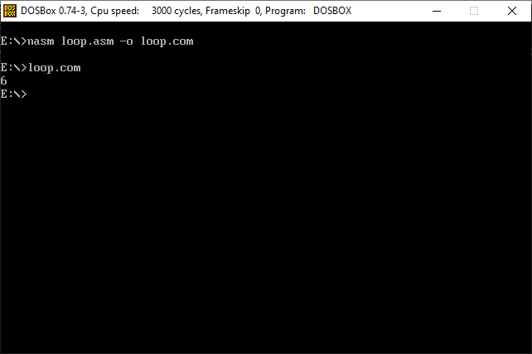 XOR CX,CX

MOV DX,0

.REPEAT_DIVISION_AND_STORE_IN_STACK

XOR DX, DX

DIV BX

PUSH DX

INC CX

CMP AX, 0

JNZ .REPEAT_DIVISION_AND_STORE_IN_STACK

.PRINT_DIVISION_AND_STORE_IN_STACK

POP DX

ADD DL, '0'

MOV AH, 02H

INT 21H

LOOP .PRINT_DIVISION_AND_STORE_IN_STACK

POP AX

ret

TASK #03:

ORG 100H

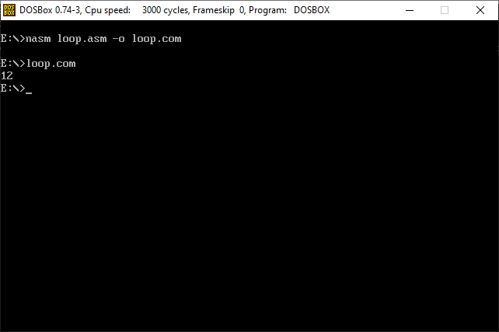MOV AX, 36

MOV BX, 6

DIV BX

print:

PUSH AX

MOV BX, 10

XOR CX,CX

MOV DX,0

.REPEAT_DIVISION_AND_STORE_IN_STACK

XOR DX, DX

DIV BX

PUSH DX

INC CX

CMP AX, 0

JNZ .REPEAT_DIVISION_AND_STORE_IN_STACK

.PRINT_DIVISION_AND_STORE_IN_STACK

POP DX

ADD DL, '0'

MOV AH, 02H

INT 21H

LOOP .PRINT_DIVISION_AND_STORE_IN_STACK

POP AX

ret